- Open a new Excel workbook, enable the Developer tab, and record a simple macro that enters your name into cell A1 and applies bold formatting.
ANSWERS:

- Download a sample dataset of 10 food delivery orders (with columns like Order ID, Restaurant, Amount, Status) and record a macro that formats the header row with a background color and auto-adjusts all column widths.
ANSWERS:
A (Order ID) | B (Restaurant) | C (Amount) | D (Status)
Order ID | Restaurant | Amount | Status
ORD-3001 | Swati Snacks | 450 | Delivered
ORD-3002 | Honest Restaurant | 620 | Delivered
ORD-3003 | Havmor Restaurant | 890 | Pending
ORD-3004 | Swati Snacks | 320 | Cancelled
ORD-3005 | Honest Restaurant | 1150 | Delivered

- Save your macro-enabled workbook as an .xlsm file and verify that the macro runs correctly after closing and reopening the file.
ANSWERS:

A (Order ID) | B (Restaurant) | C (Amount) | D (Status)
Order ID | Restaurant | Amount | Status
ORD-3001 | Swati Snacks | 450 | Delivered
ORD-3002 | Honest Restaurant | 620 | Delivered
ORD-3003 | Havmor Restaurant | 890 | Pending
ORD-3004 | Swati Snacks | 320 | Cancelled
ORD-3005 | Honest Restaurant | 1150 | Delivered

- Record a macro that deletes all blank rows in a list of Instagram followers (names in column A) and then sorts the list alphabetically.

Hint: Use the macro recorder to capture each step rather than writing VBA code manally.
ANSWERS:
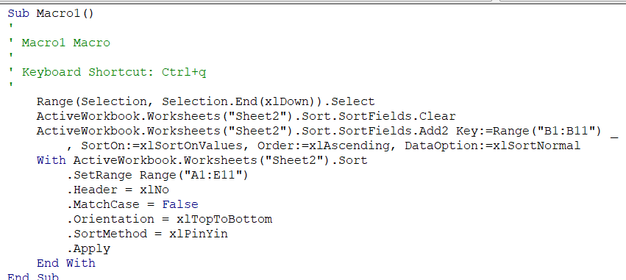

- Edit the macro you recorded in the previous task to also highlight any follower names that start with the letter 'A' in yellow.
Constraint Use only the macro recorder and Excel's built-in features—do not write or edit VBA code directly.
ANSWERS:
1 | Follower Name
2 | Rohan Mehta
4 | Ananya Gupta
5 | Vikram Singh
7 | Diya Shah
10 | Sneha Verma

